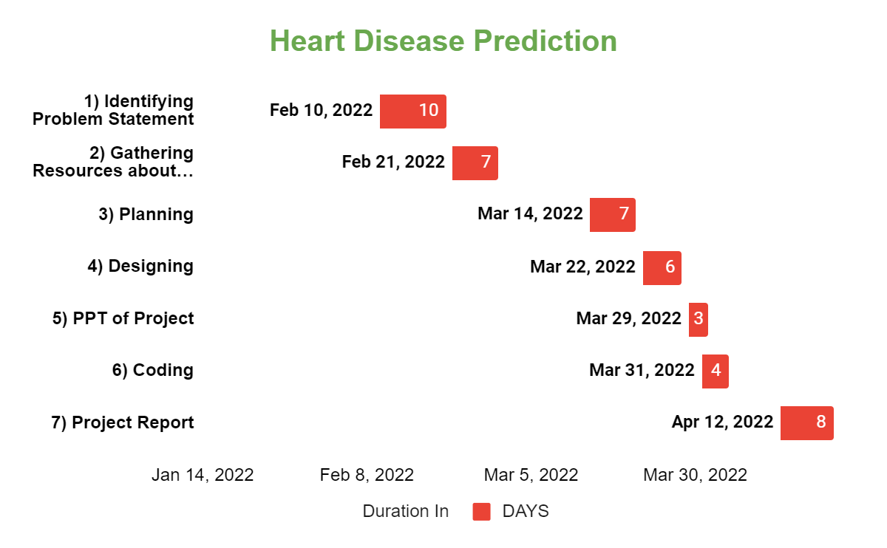

|  |  |  |
| --- | --- | --- |
| TASK | START DATE | Duration |
| 1) Identifying Problem Statement | 2/10/2022 | 10 |
| 2) Gathering Resources about Project | 2/21/2022 | 7 |
| 3) Planning | 3/14/2022 | 7 |
| 4) Designing | 3/22/2022 | 6 |
| 5) PPT of Project | 3/29/2022 | 3 |
| 6) Coding | 3/31/2022 | 4 |
| 7) Project Report | 4/12/2022 | 8 |